Buena Vista Regional Medical Center
Quick Reference Guide of Emergency Conditions and Staff Response
Contacts
Security Services   | How To Contact BVRMC Security  - Vocera: “Call Security” using Vocera pager device or dial 4700 from phone  - Security Cell Phone: 712.291.5039  - Overhead Page: dial 79 - speak clearly and calmly - repeat 3 times
House Supervisor | Cell Phone: 712.291.0294
Vocera  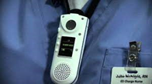 | Urgent Vocera Broadcast:  - State ‘Urgently Broadcast to Everyone” from a Vocera. Cannot make broadcast from a phone.  Panic Activation for a Urgent broadcast to Security  - Emergency Situation Alert to Security – Double click the call button.  - A one-way communication link is opened from you to security so you will not receive a verbal response back from security. If possible, verbally provide location and situation. Only you can end the call.
Announcements   | Overhead and Vocera announcements are to be stated in a clear and calm voice and repeated three (3) times for all to hear.

 | Problem/Code | Description | Response
 | Severe Weather Alert | Indicates pending severe weather conditions that are in effect for our area (Severe Thunder storms,  High Wind/Straight Wind advisories, Tornado Watches and Warnings)
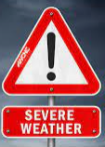 | Severe Weather Watch | Indicates that hazardous weather is possible. | Patient Access will:  Overhead Page AND Vocera “Severe Weather Watch” and type every 1 hour  - All departments should be secured: fire doors closed, windows closed, drapes pulled, blinds closed. Objects that could become projectiles should be moved to more secure locations.  - After patients and visitors are notified of the weather alert, the patient’s room door is to be closed to indicate that the room and the occupants have been prepared.
 | Severe Weather Warning | Indicates the weather event is occurring or is imminent in or around the warning area | Patient Access will:  Overhead Page AND Vocera “Severe Thunder Storm Warning is in effect” and then “Severe Thunderstorm Warning continues” every 15 minutes until cleared  - All departments should be secured: fire doors closed, windows closed, drapes pulled, blinds closed. Objects that could become projectiles should be moved to more secure locations.  - Department operations are to continue.  - All in-patient clinical areas will proceed to cover patients with extra blankets and move the beds away from the windows.  - Having visitors, guests, and employees take shelter is not required unless the thunderstorm warning is changed to a tornado warning/sighting.
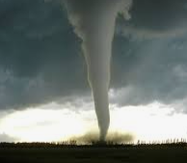 | Tornado Warning  Or  Tornado Sighted | Indicates a tornado is imminent and has been sighted in and near the watch area. | Patient Access will:  Overhead Page AND Vocera “Tornado Warning” or “Tornado Sighted” - please take cover”  - For all in-patient areas, patients who are able to ambulate are to be moved to the patient bathroom. If unable to be out of bed, proceed to cover patients with extra blankets and move the beds away from the windows.  - All patients, guests, and visitors in all areas are to be escorted to severe weather shelter areas by available staff.  - If in a stairwell, travel to the lowest possible point and get under stairs if possible. Stay away from windows Take cover in an internal room with no windows and low ceiling, close door. Hunker down, cover selves with coats, blankets, if possible. Avoid rooms with potentially flying debris and electrical equipment.
 | Security Alert of Combative or Disruptive Person | Indicates there is a disruptive situation occurring and trained assistance is needed | Overhead Page AND Vocera “Security Alert” with a location Only  - Trained security staff are to respond.  - Others stay clear of the area.
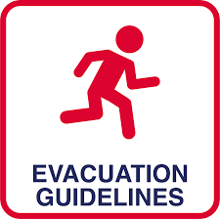 | Evacuation | Evacuating patients, visitors, & staff from an unsafe location | House Supervisor, Administrator-on-call, the Incident Commander or Fire chief will determine what type of evacuation is need. Listen for announcements.  - Partial evacuation: when a designated area of a building is evacuated to another area of the building.  - Full hospital evacuation: complete evacuation of all people within the facility.
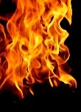 | Fire Alarm | Fire or smoke is observed and/or pull alarm activated | Patient Access will:  Overhead Page AND Vocera “Fire Alarm” with a location  Follow RACE:  - Rescue persons in danger away from fire/smoke  - Alarm -pull fire alarm pull  - Contain the fire by closing all windows and doors  - Extinguish fire only if it is safe or Evacuate if Fire Chief, A-team, House Supervisor, Incident Commander declares to do so. Follow Evacuation plan.  Use a fire extinguisher following the PASS method:  - Pull safety pin  - Aim low at base of fire  - Squeeze trigger  - Sweep from side to side across the base of the fire
 | Missing Person Infant or Child | Used in the event a child or infant has been abducted | Overhead Page AND Vocera “Missing Person” with a gender, location and approximate age  - Personnel in all areas monitor all exits from the building, asking that all individuals stop/wait until cleared by Police/Security.
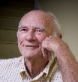 | Missing Person Adult | Used in the event a patient is missing. | Overhead Page AND Vocera “Missing Person” with gender, approximate age, description and area of elopement  - Personnel in all areas monitor all exits from the building, asking that all individuals stop/wait until cleared by Police/Security.
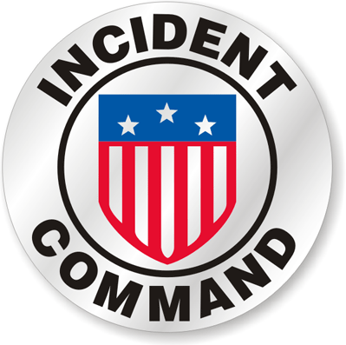 | Activate Incident Command | Disaster conditions are imminent/have occurred internally/externally.  Activates the Emergency Operations Plan | Incident Commander or appointee will:  Overhead Page AND Vocera “Activate Incident Command”  - First person receiving emergency/disaster information will immediately notify the House Supervisor and/or the Administrator On-Call  - Take direction from Incident Commander (IC) as the IC or appointee will activate Incident Command.
 | Bomb Threat | Written or oral bomb threat. | - Staff receiving bomb threat will notify or have a coworker notify House Supervisor  - Keep the caller on the line and obtain as much information as possible.  - Check caller ID, if available, write down exactly what is displayed.  - Ask for the location of the bomb, and time of detonation.  - Record the words and characteristics of the caller on the Bomb Threat form.  - House supervisor will call 911 and then notify Administrative Team.  - Listen for additional instructions.  - Do not touch items; turn off all 2-way radios, cell phones, Vocera, and electronic devices.
 | Media Procedures | Public Information Officer (PIO) coordinates the release of information to media  PIO: Executive Director of Marketing or designee | All media inquiries need to be directed to the PIO or Administrator On-Call / Incident Commander. BVRMC staff and affiliates are strictly prohibited from communicating via forms of social media, phone calls, or texting relating to any information surrounding hospital operations.
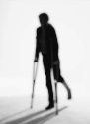 | Visitor Injuries | Any visitor that is/may be injured while on hospital grounds | Provide aid and assist as needed.  Call 911 for emergency care/lifting in the parking lots.  Call 911 for emergency care/lifting in the hospital setting.  - View the area of the injury to determine if a hazard exists.  - Notify the Safety Coordinator / House Supervisor  - Complete an Event Report
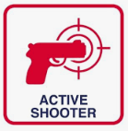 | Active Shooter | Indicates potentially violent situation. | 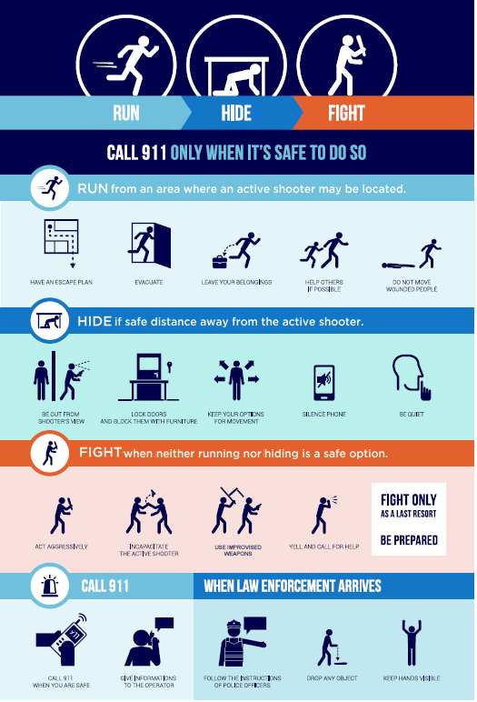  - Call 911 when safe to do so.  - When safe use Vocera to “Urgently Broadcast to Everyone” - Active Shooter & Location of Active Shooter.  - When safe overhead page by dialing 79 and announce Active Shooter & Location of Active Shooter.  - When safe, dial 77 on a hospital telephone and announce Active Shooter & location of the active shooter.

Location of Emergency Equipment:
AEDs  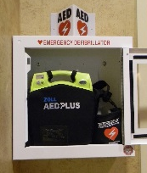 | 1st Floor:  - Bistro entrance (just inside to the left)  - Main entrance (across from Gift Shop)  - Hallway between BV Clinic/Specialty Clinic  - Cardiopulmonary (stress test room)  - Oncology  - Cardiac Rehab  BV General Surgery building  - Supply Room |  | East 2nd & 3rd Floors:  - Kitchenettes  - Hope Harbor  Outside Hospital Building:  - Fitness & Health Center (both levels)  Basement:  - Wall across from stairway / elevator
Patient Go Bags  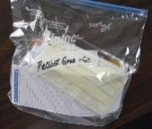 | Contain supplies for patients in the event an evacuation from the hospital is necessary | Located:  - 2nd floor conference room Incident Command Cabinet # B023 (35 bags)  - Materials Management (35 bags)
Incident Command  Go Bags  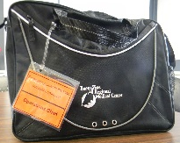 | Contain supplies for the Incident Command operations | Located:  - 2nd floor conference room Incident Command cabinet # B023 (5 bags)  - Emergency Department (in the Equipment Room – also contains IC vests)  - Law Enforcement Center (LEC) (Situation Room – also contains IC vests)  - St. Mark’s Lutheran Church (secretary area closet)  - Grace Lutheran Church (conference room closet)  - Safety Coordinator Office #2224
Demolition Bags  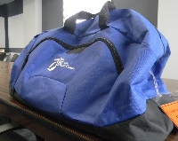 | Contain emergency supplies needed to either access or exit areas of the facility that are otherwise inaccessible due to facility damage and debris | Located:  - 2nd floor conference room Incident Command cabinet # B023  - Emergency Department (Equipment Room)  - Med/Surg (Equipment Storage Room #2025)  - BV General Surgery building (basement)

Locations of Safety Data Sheets (SDS):
 | Computer :  - Go to BVRMC Intranet  - Click on BVRMC Quick Links  - Scroll down to Safety, click on Safety Data Sheets  QR Barcode  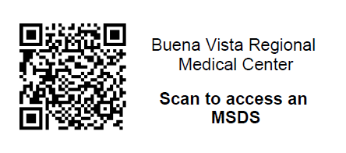  How to use the QR Barcode to find the Safety Data Sheets:  - Open up the camera app on the cell phone  - Point the camera at the QR box like you are going to take a picture of it  - Tap the notification that pops up to open the link associated with the QR code.

